These are ideas pulled together to encourage your child to think about projects for upcoming Earth Day. Included ate various grade level suggestions that will encourage creativity, problem solving, and use of the Design Process. Thank you PBS for all the work you do for our students!

Ideas Brought to you by PBS LearningMedia

Want more? Search over 100,000 resources in PBS Learning Media to find exactly what you need for your classroom. Our students are the future caretakers of our Earth. These fun Earth Day activities help empower kids to have a positive impact on the planet. From recycled art projects to farming simulations, here’s how to roll out the green carpet in your classroom on Earth Day this year. All of these are just ideas and can be adjusted to home learning to fit your needs. Some links were replaced to help with the projects. (link on links provided in titles)
1. Engineering for Good (6–8th ) Design and Create to Solve a Problem
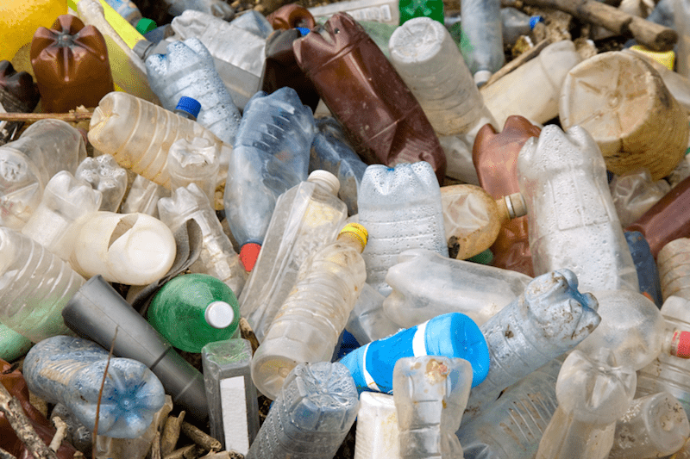
Everyone knows that drinking plenty of H₂O is good for them, but they may not realize the impact all those plastic water bottles have on the environment. In this project-based learning unit, they’ll design their own solutions for this issue by using engineering. Then they can create digital stories to share their ideas with the community.
Bonus: The lessons are aligned with the NGSS Engineering Design Standards.
2. Design It … Build It! Earth Day Activities (K–12th ) Create and Recycle
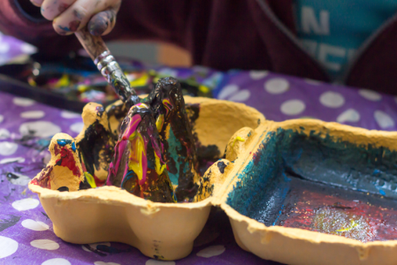
In this art activity, students learn how to take their ideas from paper to reality. They’ll use recyclable materials to design, draw, and build a creature, building, or whatever else they can imagine. FUN and CREATIVE! Through videos, activities, and lessons, students learn about the importance of recycling. They’ll also learn about which items should be recycled, reused, or put in a landfill.

3. Effects of Environmental Change (3–5th ) Design and Create a Habitat
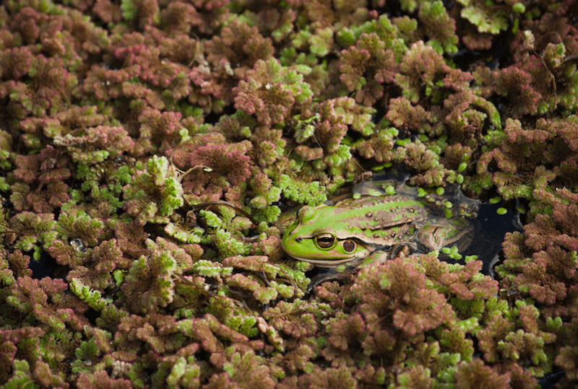
What animal is hiding? This lesson helps kids understand what could happen to plants and animals if they don’t adapt when their environment changes. (The following website has a great lesson plan and videos to learn about creatures and environmental changes.
EFFECTS of ENVIRONMENTAL CHANGES (these are just ideas and can be adjusted to home learning)
First, students read The Great Kapok Tree: A Tale of the Amazon Rain Forest. Then, they watch a video about animal camouflage. Next, they play a predator-prey simulation game. Finally, they do a fun web activity to explore what would happen to living things if the air’s oxygen concentration changed.
** Have your child create a habitat for an animal in a healthy environment and then describe what would happen if the environment changed. How must your animal adapt?

4. Snapshot of U.S. Energy Use (3–12th ) Design and Create ways to Reduce CO2 footprint
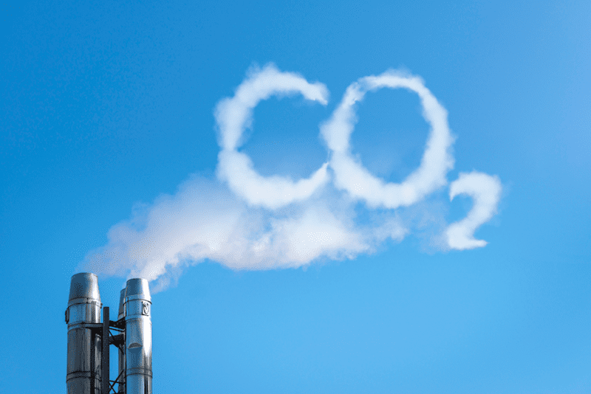
https://klru.pbslearningmedia.org/resource/nvdtwm-sci-climatecycles/understanding-natural-climate-cycles-decoding-the-weather-machine/
How much energy do we consume simply by living our daily lives? This video, adapted from NOVA/FRONTLINE, helps students understand the amount of energy burned during daily activities. The video also explains how much CO₂ those activities contribute to the atmosphere. Can you think of a way we can reduce our CO2 footprint? Can you invent a tool to help this problem? Try an carbon dioxide experiment.

5. Dreaming in Green (4–8th ) Design a storyboard with script to make a video.
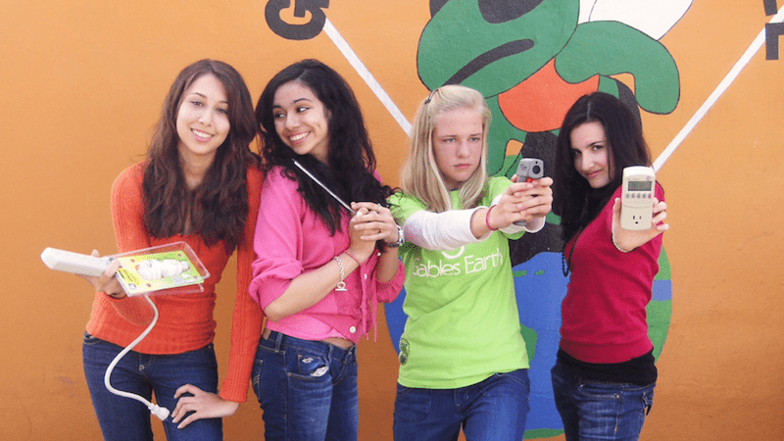
This video tells the story of four girls in Miami who joined forces to become the Green Team in order to reduce their school’s carbon footprint—and save money at the same time. After watching this video, your child may be motivated to conduct their own energy audit at your school or home.

6. Team Marine (4–8th ) Help influence our community.
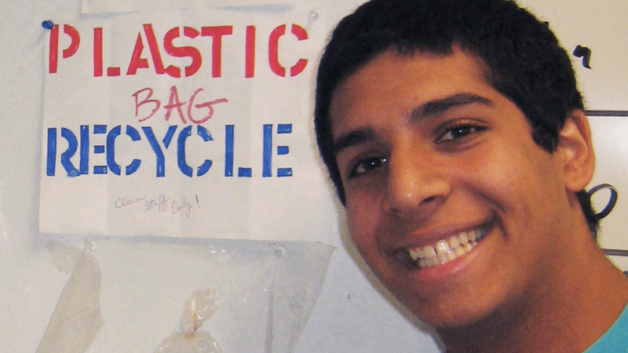
Students learn they have the power to influence change in their community after watching this video about Team Marine. This group of students convinced decision-makers to ban plastic bags in their town after they realized the negative impact the bags have on the ocean and sea life. What would you promote to help our environment? How could you influence others to help with your idea?

7. Ecosystem Explorer (2–8th ) Design a habitat complete with ecosystem.
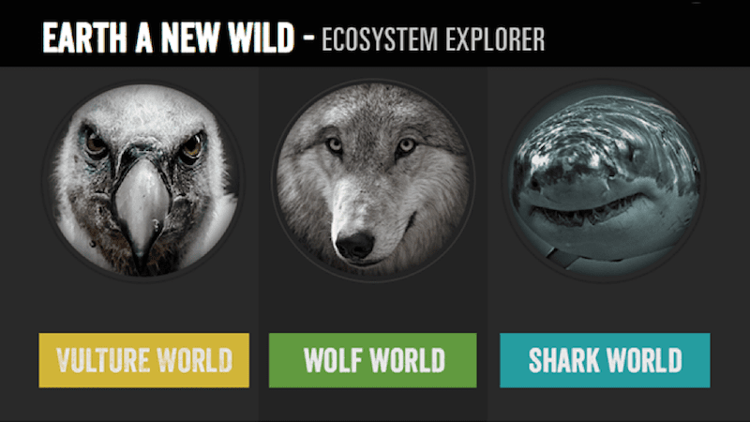 https://klru.pbslearningmedia.org/collection/videos-and-interactive/
Inspired by the PBS series EARTH A New Wild, students get to explore the ecosystems of different animals. They’ll watch can videos about the relationship between animals, their habitat, and ecosystem. Have your child research an animal of their interest. Next, design a project to show that animal’s ecosystem and the food chain. Make a short video explaining your project.

8. Cornucopia: Environmental Simulation (It takes a time to load)
(6–10th ) Design and Create an environmentally efficient farm.
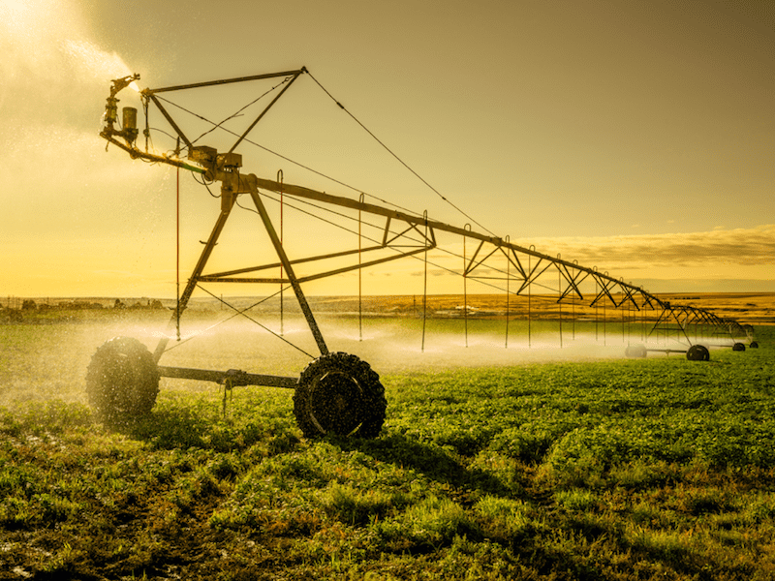
If you’re looking for Earth Day activities for students who like video games, check out this fast and fun simulation. It lets students manage a plot of farmland. The challenge is to make their farm as successful as possible. They’ll also need to keep an eye on their water meter and crop yields. They’ll learn about water and land resource needs, identify how weather and climate affect water availability and food production, and investigate how agricultural technology affects water use. ****Design and create a farm using recycled materials. What kind of technology will you use? How will you provide enough water for the farmland? Can you create an irrigation system for your design?

9. Do Renewable Energy Projects at Home or In Class (Adapt for grade levels)
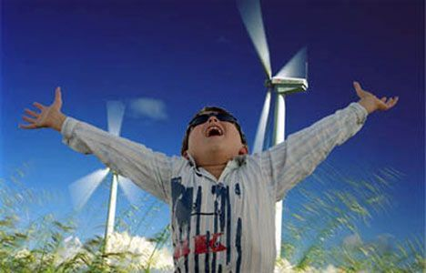
Reading the science of renewable energy in a textbook can get a little dry so infuse some excitement into the lessons with hands-on projects. There are hundreds of projects that show renewable energy in action in the form of solar, wind, hydropower energy and more. Here are a few to get you started:
- Design a Car – Create a toy car powered by wind, air force, battery, or the sun
- Various Experiments and information: via Science Experiment for Kids. (Free 30Day no credit card required
- Water Heater – Can solar energy heat water effectively? Show your students that the answer is “yes” with this experiment best for kids in grades 4 and up. Tutorial via Science Buddies.
- ( PrK-2nd) Light Box – Explain light refraction in a solar energy lesson that involves cardboard boxes, plastic bottles, and some creative decorating from kids as young as preschool age. Tutorial via True Aim Education.
- Solar Oven Pizza Box Video Recycle that pizza delivery box by using it as a solar oven. No need to worry that your kids will burn themselves on this cooking project, either. (Fun for all grade levels.)
- (K-3rd) Kinetic Energy Video Wind Wheel with JoJo
( 3-5th) Wind Energy Show students how wind and water can generate energy.

10. The First Earth Day (6–12th )
Students may think Earth Day began as a celebration. If they do, what they may not realize is that when it was first observed in 1970, it was a day of protest and demonstrations throughout the United States. This video includes historical photos of the first Earth Day that show the beginning of the U.S. movement to effect environmental change. If you were attending an Earth Day event, what kind of design would you create to show you’re your thoughts and support?

11. Cars That Power the Grid (6–12th )
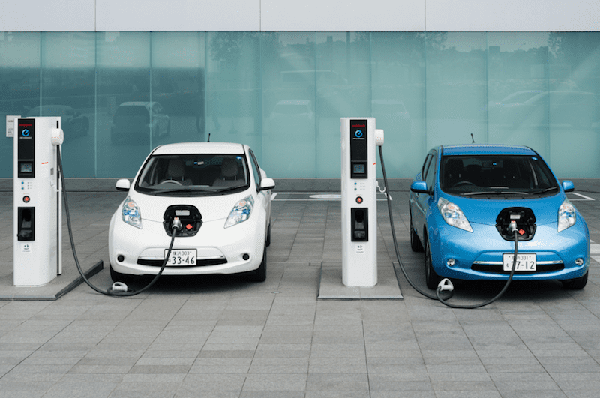 (you do not have to join to view) Electric cars are becoming more common, but do your students know that their cars may one day indirectly power things like refrigerators? In this STEAM video, students learn how engineers are researching ways to use electric vehicles to feed power back to the electric grid. Design and create an idea you might have to promote the use of electric transportation. How will it work?

12. Recycling and Composting (K–5th )
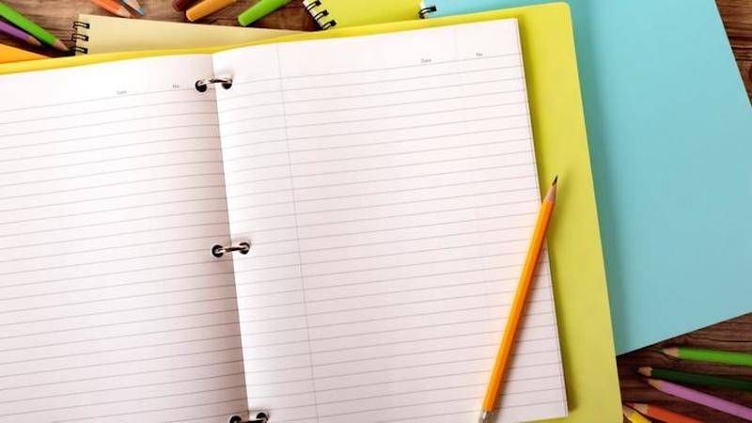 In this lesson, students learn about the value of renewable resources and expand their understanding of recycling and composting. The lesson includes videos and discussions about visiting a recycling plant and making recycled paper. After watching the second video, students will make their own recycled paper out of materials like cornstarch, water, aluminum foil, and newspaper. Children could design a small compost area. What steps do you need to create and nurture the compost pile?

Posted by Marlana Martinelli
All Posts
Related Content
A Fun Earth Day Recycled Garden Activity

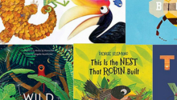 25 Great Children's Books for Earth Day

Try This Free Earth Day Digital Breakout for Grades 2–5

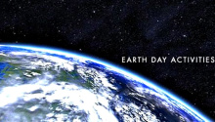 Awesome Earth Day Math and Science Activities
Explore WeAreTeachers

30 Great Educational Netflix Shows

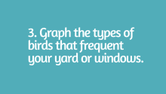 This Principal's List of Things to Do During COVID Closures Is Going Viral for All the Right Reasons

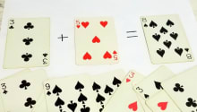 16 Card Games That Will Turn Your Students Into Math Aces

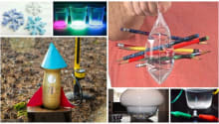 35 5th Grade Science Projects That Will Blow Your Students' Minds

